**Observer Patterns = publishers + subscribers**

The observer pattern defines a **one-to-many dependency** **between a set of objects**

🡪 so that when one object changes state, all of its dependents are notified and updated automatically.

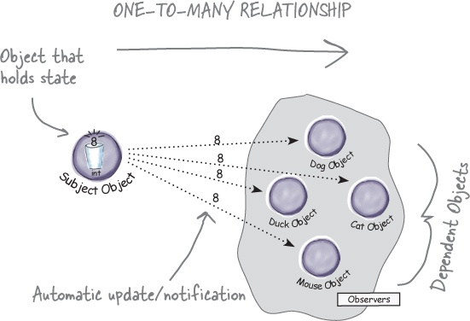

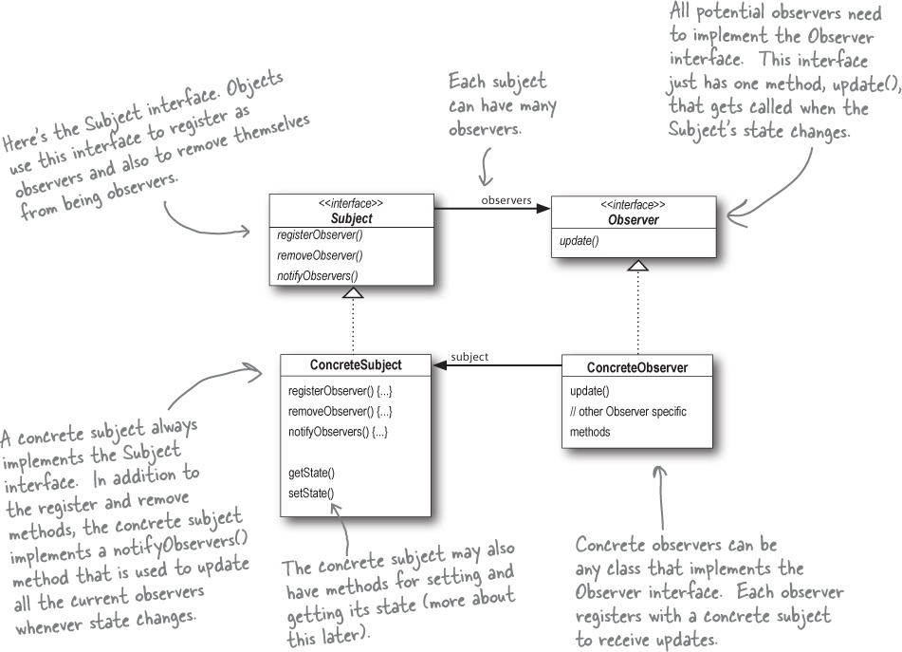

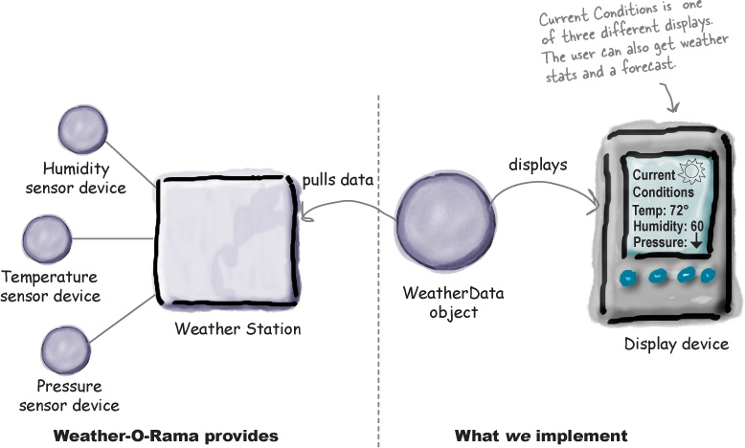

Designing Weather Station

